SR-DH series

DH60/DH100/DH120(-R/-W）Gen4

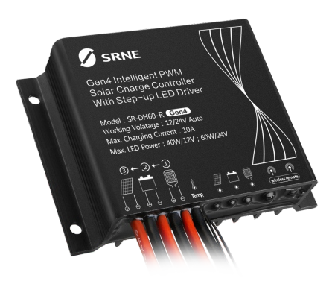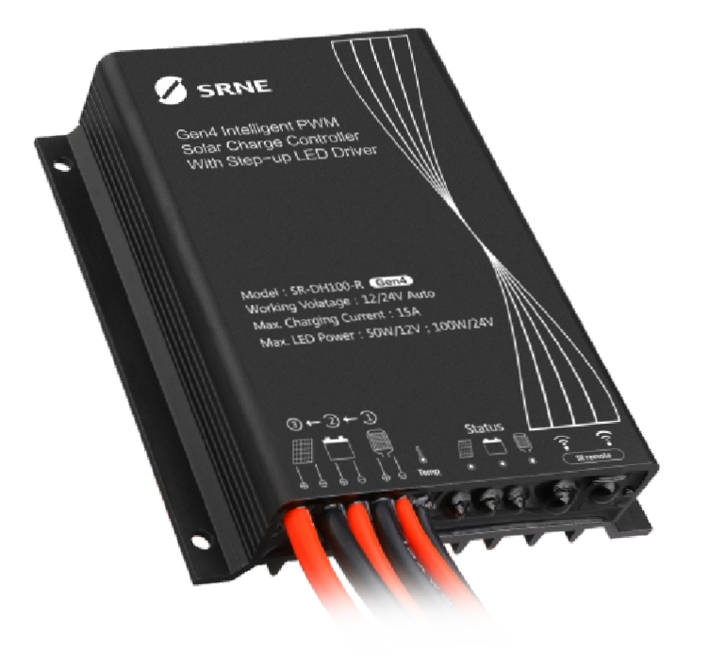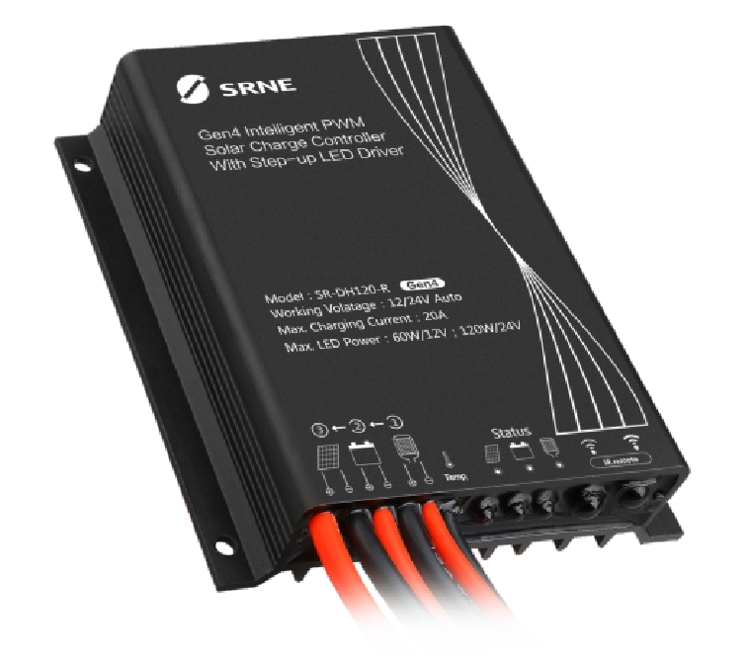Intelligent wireless LED dimming type
All-in-one constant current solar street light controller

SR-DH120-R SR-DH100-R SR-DH60-R

010 101
101 010
010 101
PWM
Features
Power
100%

10%
100% 30% soc

- Whole new 2.4G wireless/infrared remote control design allows manual modification of controller parameters and reading of system information.
- Full digital high precision constant current control, achieving the maximum efficiency of 96%.
- Human motion infrared/microwave sensing function, with sensing delay time settable.
- 9-Period light dimming and pre-dawn lighting design, working hours settable from 0 hours to 15 hours, power settable from 0% to 100%.
- Both lead-acid battery and lithium battery are applicable, operating parameters can be set by remote control.
- A variety of intelligent power modes are available for choice, with load power adjustable automatically according to the battery level.
- Very low sleep current for long-distance transportation and storage.
- System status recording allows recording of up to 7 days of system status, realizing full monitoring of the system.
- Metal shell, IP67 waterproof rating, applicable to a variety of harsh environments.
- High precision digital step-up constant current control algorithm provides high efficiency and high constant current accuracy, extending the service life of battery.
- Battery charge and discharge high and low temperature protections guarantee that when the temperature exceeds a certain temperature, the number of loads will be reduced or the load will be turned off.
- Battery reverse polarity protection, LED short circuit and open circuit protection, etc. are provided for full protection of the system.
www.szshuori.com

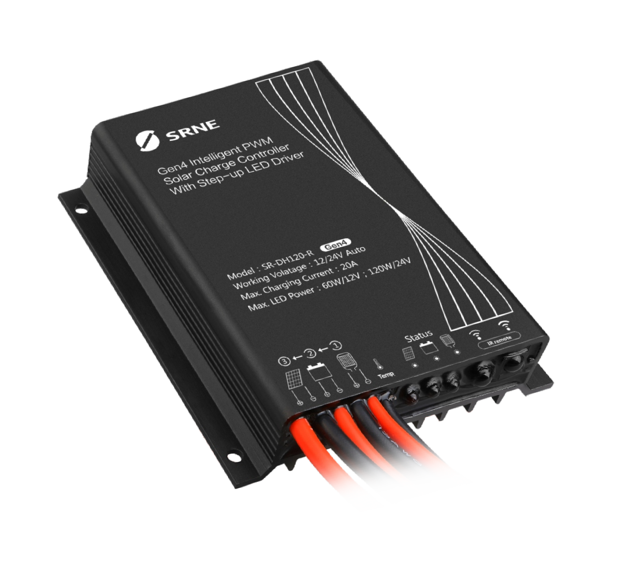 Exterior

Infrared receiving
Battery indicator
Load indicator
Charge indicator

Wiring Diagram
IR remote
Status
Model：SR-DH120-R
Working Volatage：12/24V Auto Max. Charging Current：20A
Max. LED Power：60W/12V；120W/24V
Gen4 Intelligent PWM Solar Charge Controller With Step-up LED Driver

www.szshuori.com

State Indicators
DH120/100 dimensions:
Overall dimensions: 82*100*20mm Mounting dimensions: 86*75mm Mounting hole diameter: φ3.5mm
75
Φ3.5
82

DH60 dimensions：
Overall dimensions: 82*58*20mm Mounting dimensions: 43*75mm Mounting hole diameter: φ3.5mm
75
www.szshuori.com
Φ3.5
58
43
20

LED indicator | Indication  content | Status | Function | Remote control system status
 | Solar panel indication | Steady on | Solar panel voltage is higher than light control voltage | Idle
 |  | Off | Solar panel voltage is lower than light control voltage | Idle
 |  | Slow flash | In charging | Charging
 |  | Double flash | Battery is fully charged | Fully charged
 |  | Quick flash | Lithium battery BMS protection Battery overvoltage;PV panel overvoltage Over temperature (ambient temperature) | E-BMS Battery overvoltage PV panel overvoltage Over temperature
 | Battery indication | Steady on | Battery works properly | Idle
 |  | Off | Battery is not connected or lithium battery protection  board overdischarge protection | /
 |  | Quick flash | Battery over-discharge | Over discharge
 |  | Single flash (One flash per 10 seconds) | Overdischarge, sleep | /
 | Load indication | Steady on | Load is turned on | Discharging
 |  | Off | Load is turned off | Idle
 |  | Slow flash | Load is open circuited | Open circuit
 |  | Quick flash | Load is short circuited | Short circuit

Installation Dimensions
82
100
86
20

Parameters

www.szshuori.com

Items |  | Values | Adjustable |  | Default
Model | DH60 | DH100 | DH120
Remote control type | 2.4G wireless remote control: -W Infrared remote control: -R
System voltage | 12V/24V
Zero load loss | -R ：<10mA/12V；<15mA/24V  -W：<32mA/12V；<38mA/24V
Sleep loss | <0.8MA/12V；<8MA/24V
Maximum charge current | 10A | 15A | 20A
Solar input voltage | ≤ 55V
Typical efficiency of constant current source | 90% ～ 96%
Output power | 40W/12V  60W/24V | 50W/12V  100W/24V | 60W/12V  120W/24V
Output current | 50mA～2000mA | 50mA～3300mA | 50mA～4000mA | √ | 330mA
Over voltage | Lead-acid battery: 16V; lithium battery: charge voltage +2V
Equalizing charge voltage | Lead-acid battery: 14.6V; lithium battery: no equalizing charge
Equalizing charge  interval | 30 days
Boost charge voltage (lead-acid)  Charge voltage (lithium) | 9.00V ～17.00V, settable |  |  | √ | 12.45V
Floating charge voltage (lead-acid)  Charge return voltage (lithium) | 9.00V ～17.00V, settable |  |  | √ | 12.00V
Over discharge voltage | 9.00V ～17.00V, settable |  |  | √ | 09.20V
Over discharge return voltage | 9.00V ～17.00V, settable |  |  | √ | 10.20V
Temperature compensation | Lead-acid battery: -3.0mV/℃/2V; lithium battery: no compensation
Current accuracy | < 3%
Light control voltage | 3V ～ 11V |  |  | √ | 5V
Light control delay | 5s～60s/2min～60min |  |  | √ | 10s
Operating temperature | -35℃ ～ +65℃
IP rating | IP67
Weight | 150g | 280g | 280g

